|  |  |
| --- | --- |
| Name: | Prerna Sunil Jadhav |
| Sap Id: | 60004220127 |
| Class: | T. Y. B. Tech (Computer Engineering) |
| Course: | Ubiquitous computing Laboratory (Honors) |
| Experiment No.: | 04 |

**AIM:** To Implement application for Human-Computer Interaction.

**CODE**:

AiVirtualMouseProject.py:

import cv2

import numpy as np

import HandTrackingModule as htm

import time

import autopy

wCam, hCam = 640, 480

frameR = 100

smoothening = 7

pTime = 0

plocX, plocY = 0, 0

clocX, clocY = 0, 0

cap = cv2.VideoCapture(0)

cap.set(3, wCam)

cap.set(4, hCam)

detector = htm.handDetector(maxHands=1)

wScr, hScr = autopy.screen.size()

while True:

    success, img = cap.read()

    img = detector.findHands(img)

    lmList, bbox = detector.findPosition(img)

    if len(lmList) != 0:

        x1, y1 = lmList[8][1:]

        x2, y2 = lmList[12][1:]

    fingers = detector.fingersUp()

    cv2.rectangle(img, (frameR, frameR), (wCam - frameR, hCam - frameR),

    (255, 0, 255), 2)

    if fingers[1] == 1 and fingers[2] == 0:

        x3 = np.interp(x1, (frameR, wCam - frameR), (0, wScr))

        y3 = np.interp(y1, (frameR, hCam - frameR), (0, hScr))

        clocX = plocX + (x3 - plocX) / smoothening

        clocY = plocY + (y3 - plocY) / smoothening

        autopy.mouse.move(wScr - clocX, clocY)

        cv2.circle(img, (x1, y1), 15, (255, 0, 255), cv2.FILLED)

        plocX, plocY = clocX, clocY

    if fingers[1] == 1 and fingers[2] == 1:

        length, img, lineInfo = detector.findDistance(8, 12, img)

        print(length)

        if length < 40:

            cv2.circle(img, (lineInfo[4], lineInfo[5]),

            15, (0, 255, 0), cv2.FILLED)

            autopy.mouse.click()

    cTime = time.time()

    fps = 1 / (cTime - pTime)

    pTime = cTime

    cv2.putText(img, str(int(fps)), (20, 50), cv2.FONT_HERSHEY_PLAIN, 3,

    (255, 0, 0), 3)

    cv2.imshow("Image", img)

    cv2.waitKey(1)

HandTrackingModule.py:

import cv2

import mediapipe as mp

import time

import math

import numpy as np

class handDetector():

    def __init__(self, mode=False, maxHands=2, detectionCon=0.5, trackCon=0.5):

        self.mode = mode

        self.maxHands = maxHands

        self.detectionCon = detectionCon

        self.trackCon = trackCon

        self.mpHands = mp.solutions.hands

        self.hands = self.mpHands.Hands(self.mode, self.maxHands,

                                        self.detectionCon, self.trackCon)

        self.mpDraw = mp.solutions.drawing_utils

        self.tipIds = [4, 8, 12, 16, 20]

    def findHands(self, img, draw=True):

        imgRGB = cv2.cvtColor(img, cv2.COLOR_BGR2RGB)

        self.results = self.hands.process(imgRGB)

        if self.results.multi_hand_landmarks:

            for handLms in self.results.multi_hand_landmarks:

                if draw:

                    self.mpDraw.draw_landmarks(img, handLms,

                                               self.mpHands.HAND_CONNECTIONS)

        return img

    def findPosition(self, img, handNo=0, draw=True):

        xList = []

        yList = []

        bbox = []

        self.lmList = []

        if self.results.multi_hand_landmarks:

            myHand = self.results.multi_hand_landmarks[handNo]

            for id, lm in enumerate(myHand.landmark):

                # print(id, lm)

                h, w, c = img.shape

                cx, cy = int(lm.x * w), int(lm.y * h)

                xList.append(cx)

                yList.append(cy)

                self.lmList.append([id, cx, cy])

                if draw:

                    cv2.circle(img, (cx, cy), 5, (255, 0, 255), cv2.FILLED)

            xmin, xmax = min(xList), max(xList)

            ymin, ymax = min(yList), max(yList)

            bbox = xmin, ymin, xmax, ymax

            if draw:

                cv2.rectangle(img, (xmin - 20, ymin - 20), (xmax + 20, ymax + 20),

                              (0, 255, 0), 2)

        return self.lmList, bbox

    def fingersUp(self):

        fingers = []

        if self.lmList[self.tipIds[0]][1] > self.lmList[self.tipIds[0] - 1][1]:

            fingers.append(1)

        else:

            fingers.append(0)

        for id in range(1, 5):

            if self.lmList[self.tipIds[id]][2] < self.lmList[self.tipIds[id] - 2][2]:

                fingers.append(1)

            else:

                fingers.append(0)

        return fingers

    def findDistance(self, p1, p2, img, draw=True,r=15, t=3):

        x1, y1 = self.lmList[p1][1:]

        x2, y2 = self.lmList[p2][1:]

        cx, cy = (x1 + x2) // 2, (y1 + y2) // 2

        if draw:

            cv2.line(img, (x1, y1), (x2, y2), (255, 0, 255), t)

            cv2.circle(img, (x1, y1), r, (255, 0, 255), cv2.FILLED)

            cv2.circle(img, (x2, y2), r, (255, 0, 255), cv2.FILLED)

            cv2.circle(img, (cx, cy), r, (0, 0, 255), cv2.FILLED)

        length = math.hypot(x2 - x1, y2 - y1)

        return length, img, [x1, y1, x2, y2, cx, cy]

def main():

    pTime = 0

    cTime = 0

    cap = cv2.VideoCapture(0)

    detector = handDetector()

    while True:

        success, img = cap.read()

        img = detector.findHands(img)

        lmList, bbox = detector.findPosition(img)

        if len(lmList) != 0:

            print(lmList[4])

        cTime = time.time()

        fps = 1 / (cTime - pTime)

        pTime = cTime

        cv2.putText(img, str(int(fps)), (10, 70), cv2.FONT_HERSHEY_PLAIN, 3,

                    (255, 0, 255), 3)

        cv2.imshow("Image", img)

        cv2.waitKey(1)

if __name__ == "__main__":

    main()

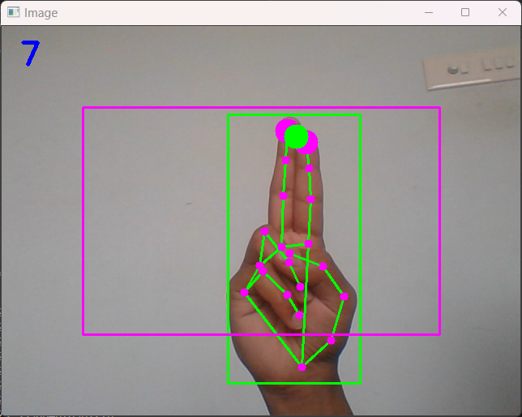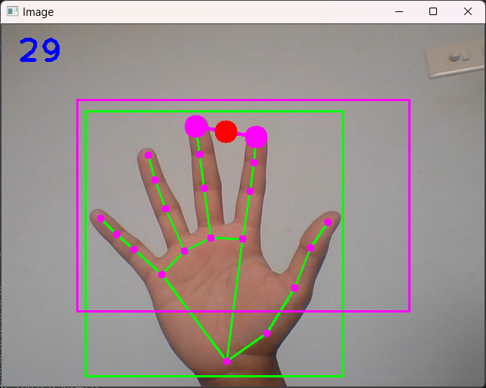**Output:**

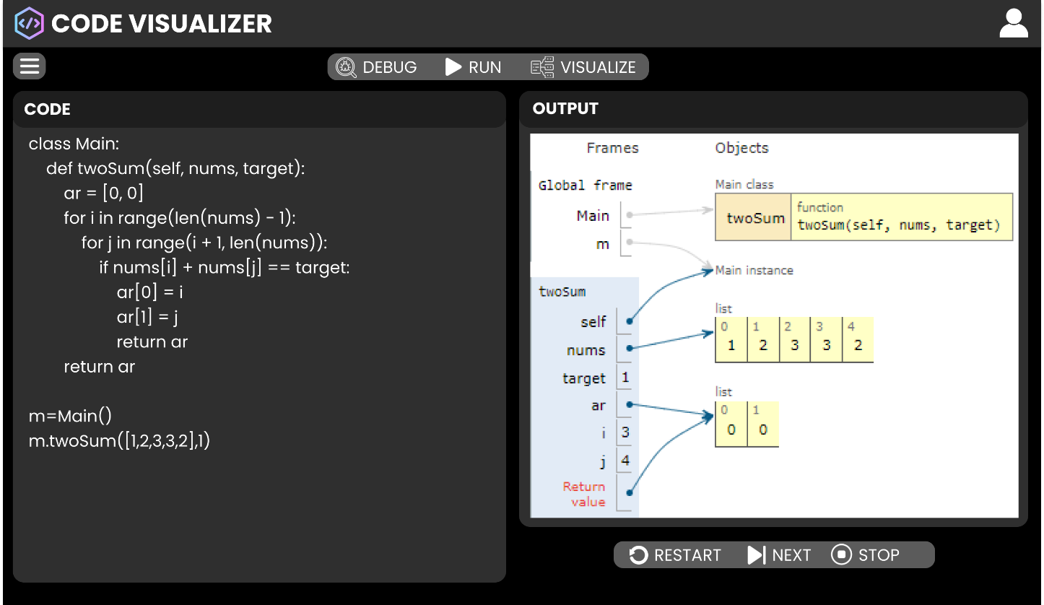**Figma UI:**